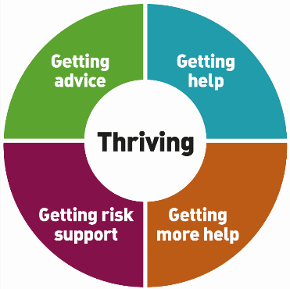
EBSA THRIVE FRAMEWORK 2020/21

Multiagency response to children anxious to return to school (emotionally based school avoidance; EBSA)
As part of Thrive in Education and the Inclusion Strategy there will be a new way to co-ordinate multiagency support around children and young people who are anxious about returning to school in September, either as a result of pre-existing concerns about attending school (emotionally based school avoidance; EBSA) or more specific COVID-19 related anxieties.
This will include a single referral point (via your EWO or EH school co-ordinator) and a graduated response to meeting need using the Thrive Framework. Collaboration between the following services will offer support to school staff, parents, children and young people:
- CAMHS (including i-Reach)
- Place2Be and 42nd Street – Mental Health Practitioners

- Education Welfare Service
- Early Help Team
- The Educational Psychology Service
Further details about the EBSA Thrive Framework will be shared ahead of the Autumn Term. Ideas for supporting the whole school community at the Thriving (universal) stage include:
THRIVING
An understanding that all children, families and staff returning to school from lockdown will require support and information as part of an adjustment and re-integration process that regulates concerns and anxieties about returning to the 'new normal'.

APPROACHES may include social stories about returning to school, asking children and young people on their first day back in school to note down one trusted adult in school who they can talk to, whole school projects, assemblies, photo journals and IT projects with a focus on supporting the emotional wellbeing of staff and CYP and community recovery. Supportive and flexible systems that are consistently adhered to throughout school and are regularly reviewed and updated.

RESOURCES
- Education Welfare Service’s ‘Return to school - Questions to consider’ prompt sheet for school staff.
- Educational Psychology Service’s trauma-informed transition materials and virtual support sessions which focus on community recovery as well as individual needs.
- Primary Inclusion Team (PIT)’s virtual training sessions focusing on managing risk, des-escalation strategies and supporting children who are anxious (joint with CAMHS) https://www.pitreferrals.org/cpd-courses/
- Emotional Wellbeing check in for all pupils.
- Use of online resources and support from Place2Be and 42nd Street.
- EBSA School audit tool included in the West Sussex Guidance for Schools (page 58).

If you have any questions please contact EPS@Salford.gov.uk or EWS@salford.gov.uk

