Worry Boxes
A worry box is a place that we can put our worries so that they are not kept inside our heads. It helps us to understand what we are worried about and to put them somewhere until we are ready to talk about them.
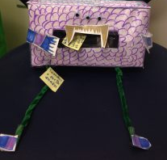

How Do You Make a Worry Box/Jar?

Let your child choose the container and decorate it as they would like. They could use paint, glitter, sequins, felt tip pens or even Paper Mache. They can decorate it however they would like with their favourite things, as a monster or in their favourite colours. It is completely up to them. Children can write or draw their worries on pieces of paper.
What kind of container makes a good Worry Box/Jar?
Glass or plastic jar with labels removed
Shoe box
Cereal box
Tissue box

Body Map

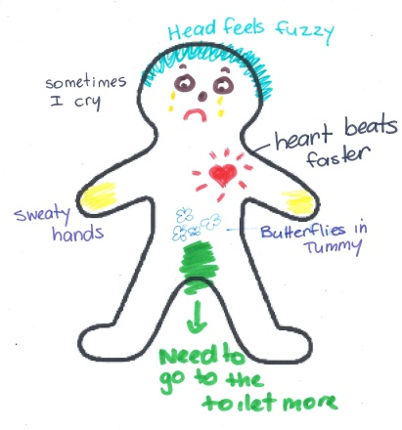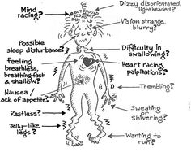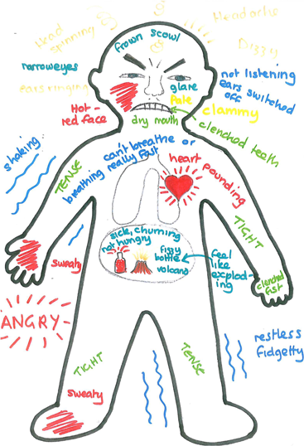

On a large piece of paper or on the ground using chalk, draw a body outline of your child. You could also draw a body outline on a piece of A4 paper.

Discuss with your child where he/she might feel worry? (e.g stomach, head, chest, hands, feet.)

What words would we use to describe worry?

What are the physical signs of worry? (e.g shaking hands, sweating, beating heart, butterflies in our stomach)

Label this on your body map.

Superhero Powers
Ask your child to think about having a special power like a superhero. Their power will help them to fight their worries. The superpowers that the children choose can tell us a lot about where they feel powerless. Have them share their superpowers and colour the superhero template giving their superhero a unique name.

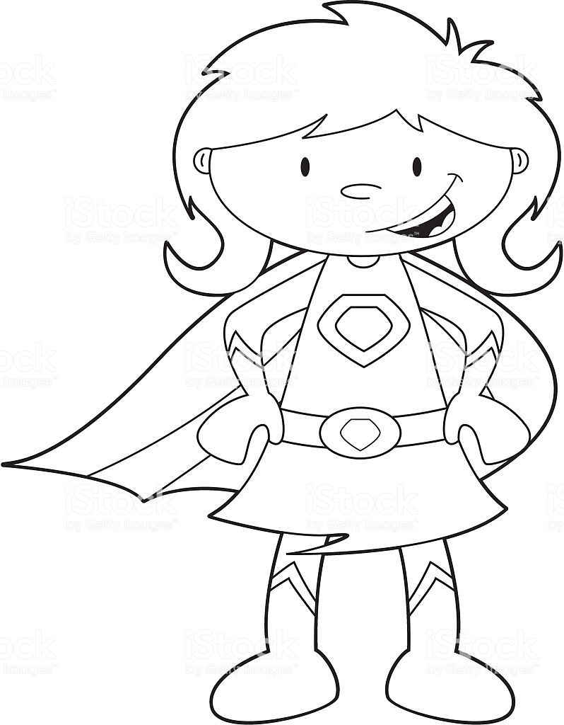

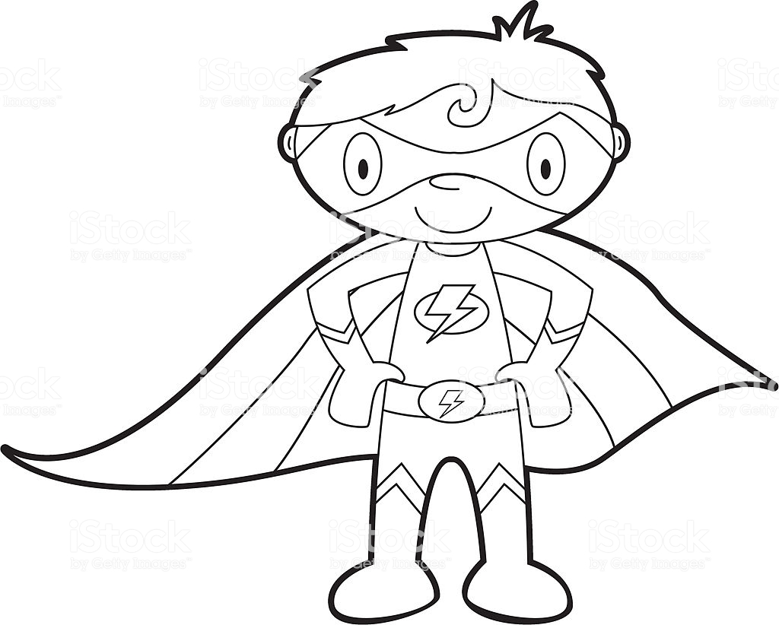

Colour your Emotions
Give your child a blank piece of paper and a selection of coloured pencils or crayons.
On one side of the paper, make a "key" and pick one colour to represent each different feeling they know (You might want to give your child a list of feelings that they need to assign a colour to – Happy, Sad, Worried, Angry, Excited, and Upset.)
On the other side of the paper draw an outline of a body which represents them. Since we have feelings all the time, your child will fill up the entire body outline, creating an abstract design using the colours they have chosen.
They need to use all the colours from the key in whatever proportion they have felt the feeling. If your child chooses yellow for happy and feels like he's been mostly happy over the past few weeks, then the majority of the finished design should be yellow.

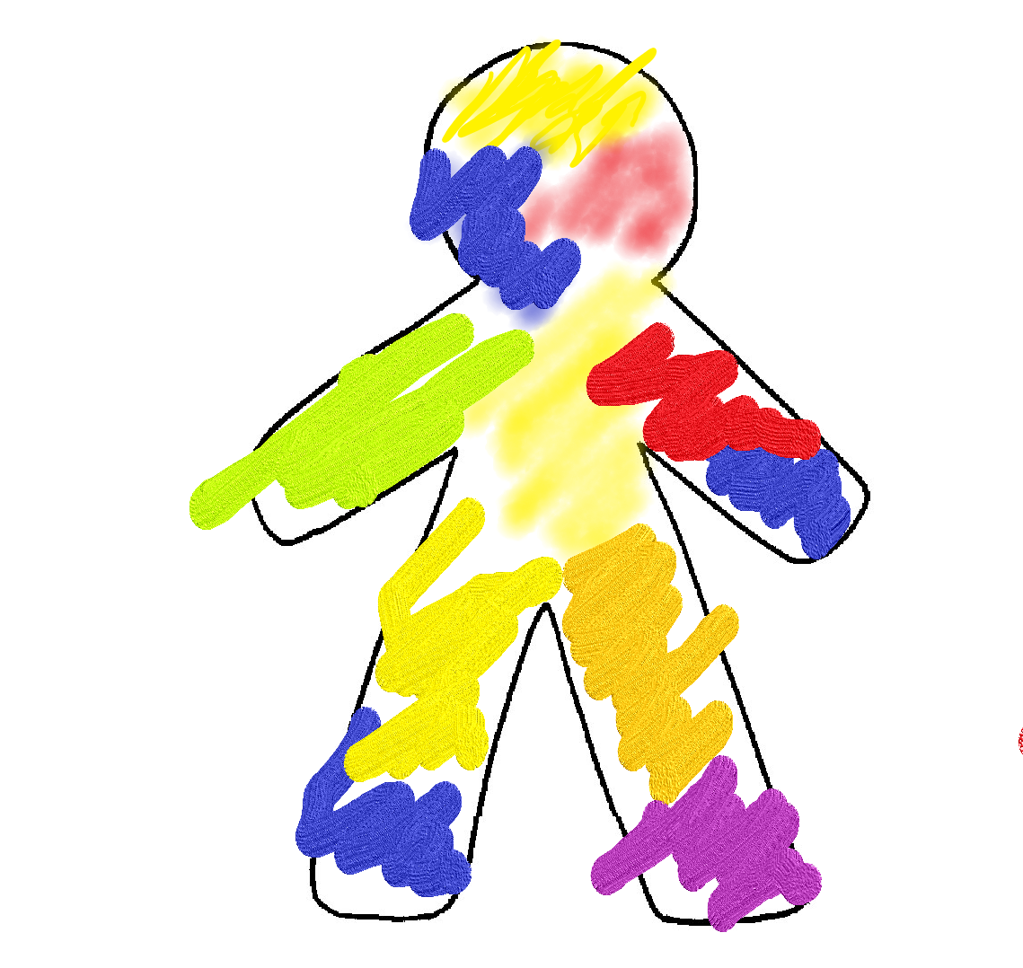

Positive Jar

Explain that when we do something positive or say something nice we can add to our positive jar. If something has made us feel happy or if you remember a time somebody made you feel special, you can add this to your jar. We want to be bucket fillers, sharing our kindness with others not buckets dippers where we take away from the nice things others do by saying things that might upset them.
What will I need
- A jar or cardboard box

- Craft materials – felt tip pens, paint, sequins, glue, tissue paper
Decorate your Jar or box using the craft materials you have available.
Add to your jar/box when you or a member of the family have done or said something positive
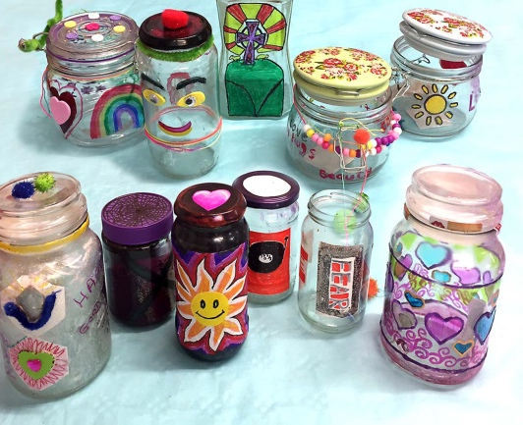
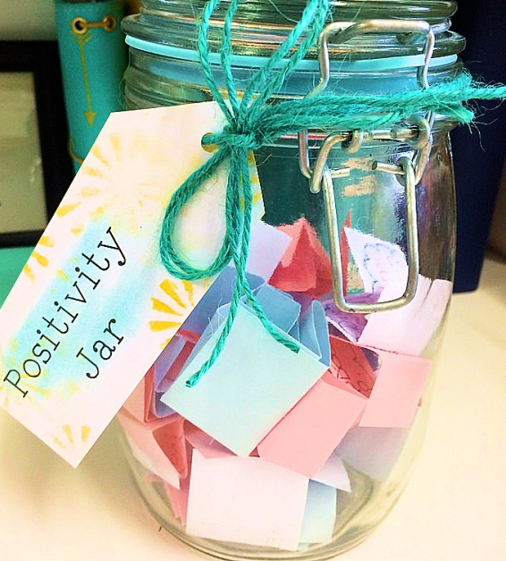

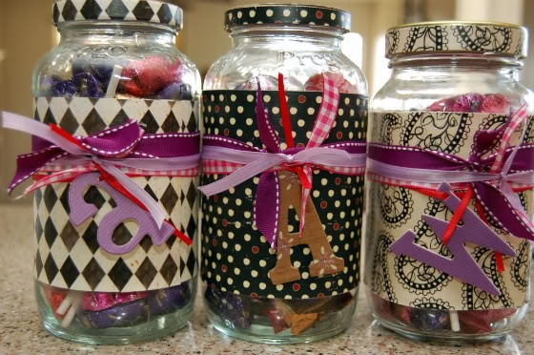

Positive Rainbow

What will I need?
- Paper
- Felt tip pens

Using a cloud template and strips of coloured paper, you can create a rainbow cloud adding a positive attribute to each strip on your rainbow.
Think about what your positives are, what is good about you, what are you good at doing?
Children can then decorate their cloud and hang their rainbow where they can see it to remind them of their positive attributes every day.

