My Reward Chart
Discuss with your child what you would like them to do to achieve stars on their chart and agree a reward they would like to work towards.
For example, for each piece of school work you complete you will get to colour a star.

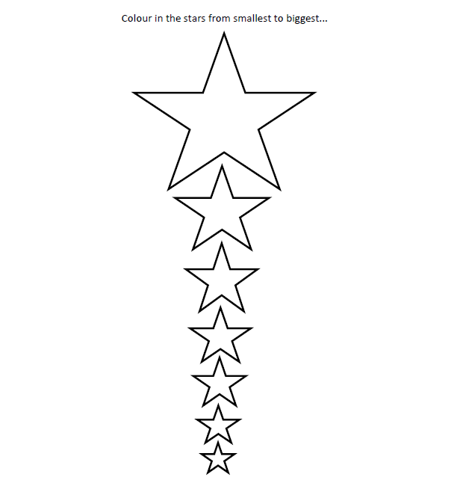
I am working towards …………………………………………

