Gloop
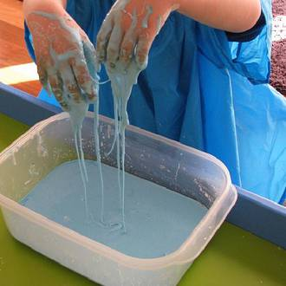
What do I need?
- Tray/washing up bowl
- 2 cups of cornflourCornflour
- Food colouring
- 1 cup of water

Making Gloop
- Place 2 cups of cornflour into the tray/bowl.
- Add 1 cup of water to the tray.
- You may also add food colouring to brighten up the gloop.
- Ask your child to mix the cornflour and water with their hands.

Talk to your child throughout and question their experiences. Use their sense to explore asking questions about the senses they are using whilst exploring.
What does it feel like?
What does it smell like?
Can you draw something with your fingers in the gloop?
Solid or Liquid?
Cornflour is made of lots of long, stringy particles. When water is added they do not dissolve in water, but they do spread themselves out. This allows the gloop to act both like a solid and a liquid. When you roll the mixture in your hands or apply pressure to it, the particles join together and the mixture feels solid. But if it is left to rest or is held up and allowed to dribble, the particles slide over each other and it feels like a liquid.

Sensory Bottles

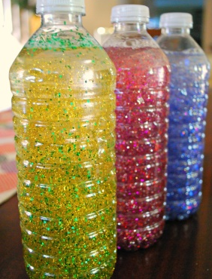
What do I need?

- Food colouring
- Glitter
- Sequins
- A plastic bottle
- Baby oil

Making sensory bottles

Give your child a plastic bottle.
Fill the bottle ¾ full with water.
Add some glitter and sequins to the bottle.
You can also colour to the water with food colouring.
Fill the remainder of the bottle with baby oil.
Place the lid on the bottle and tape shut.
Shake the bottle and watch the glitter and sequins swirl around.

What can you see?

